
AN AWARD WINNER INTERNATIONAL ORGANIZATION
A_


PROMOTING EXCELLENCE IN DENTAL EDUCATION
Over 10000 Members Strong
Presents
A Must attend seminar for you and your staff
FROM DIAGNOSIS TO TREATMENT: A GUIDE TO ENDODONTIC MASTERY
BY Sameer D. Jain DDS, MS, MSD
QUIET CANNON


On September 20, 2026(Sunday) 9:00 am till 5:00 pm
(CA Board 7 hrs C.E. units)
at
901 VIA SAN CLEMENTE, MONTEBELLO, CA 90640
(Please print in capital letters or attach your business card)
Name DR/RDH/RDA/DA Lic no
Circle one First Middle Initial Last
Address
City State Zip
Cell no ________________ Accept text message yes/no E-Mail________________________________________
ARE YOU A PDS MEMBER: YES/ NO
COMPLIMENTARY BREAKFAST, LUNCH & PARKING INCLUDED
REGISTRATION FEE |  | ONE WEEK BEFORE
Dentists Non-members | $99.00 | $109.00
Members | $89.00 | $99.00
Hygienist/R.D.A. Non-members | $79.00 | $89.00
Members | $69.00 | $79.00
FOR REGISTRATION
CALL TOLL FREE 1-866-422-5573 (1-866-4-CALL-PDS) OR 909-933-9076
TO REGISTER ONLINE VISIT US ON WWW PDSOCIETY. COM

Make check payable to

Dr. R. Salwan
President

PDS
124 EAST F STREET SUITE #8 ONTARIO, CA 91764
Dr. D.P. Singh Nagra
Chairman

Course Date & Time: 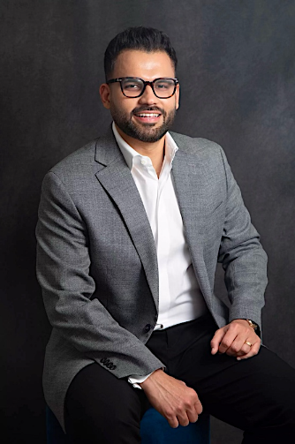
Sunday, September 26,2026, 9:00 AM - 5:00 PM Pacific Time (US & Canada)
Duration: 7 Hours

Sameer D. Jain DDS, MS, MSD
Dr. Jain is a Diplomate of the American Board of Endodontics and a leading expert in endodontics. currently practices full-time in private practice at Woodland Hills Endodontics in Los Angeles. He formerly served an Assistant Professor Director of the Urgent Care Clinic with the Department of Endodontics at Virginia Commonwealth University (VCU) School of Dentistry. Dr. Jain is recognized for his pioneering work with Dynamic Navigation Technology for minimally invasive endodontics and has authored numerous peer-reviewed publications and two books. He is also the inventor of the HYBROSONIC system—a novel heat and sonic vibration technique for root canal treatment. Dr. Jain holds multiple prestigious awards, including the MIT’s Innovator Under 35 Fellowship. He is a scientific reviewer for all the top endodontic journals and serves as a nominated member on multiple committees of the American Association of Endodontist.
From Diagnosis to Treatment: A Guide to Endodontic Mastery
This immersive, full day event is designed to elevate your practice of endodontics by covering foundational principles to advanced techniques. Dr. Sameer D. Jain will lead participants through a series of real-world case studies, emphasizing practical skills that can be immediately applied.​

Key Highlights:
- Advanced Diagnostic Techniques: Learn to identify and assess complex endodontic and non-endodontic pain conditions, enhancing your diagnostic acumen.​
- Comprehensive Coverage: Begin with foundational basics and progress to advanced strategies for managing intricate cases.​
- Restorative Techniques Post-Endodontic Treatment: Explore effective restorative methods following endodontic therapy to enhance tooth longevity and function.
- Immediate Applicability: Acquire actionable tips and techniques that can be implemented in your practice starting the following Monday.​
- Treatment Planning Process: Delve into the latest technologies and evidence-based practices to optimize clinical outcomes.​
- Decision-Making Strategies: Develop approaches for tackling challenging cases and managing unexpected complications with confidence.​

This event is sponsored by Punjabi Dental Society and Komet USA.
